Crawley Wheelers

Dave Stoke Memorial Open 10 Mile Time Trial

Saturday 1st July
On course G10/97 10 Miles
Promoted for and on behalf of Cycling Time Trials under their Rules and Regulations
Timekeepers: Chris Woods and Wendy Holden
Event Secretary: Chris Woods, 35 Stanhorn Grove, Felpham, Bognor Regis, PO228FP.
Tel: 07731601555 Email cwtimetrial@gmail.com

Emergency contact on the day
Chris Woods 07731601555

PRIZES
Individual Competition – Fastest Individuals
Overall
1st on actual time £20
2nd on actual time £10
3rd on actual time £5
Veterans on standard
1st Veteran £20
2nd Veteran £10
3rd Veteran £5
Ladies
1st Lady £20
Team
1st team of 3 £5 each

Photos will be provided by Geosnap local, Jose Espinosa and will be available after the event at:
https://geosnapshot.com/e/cycling-time-trial-crawley-wheelers-open-tt-g10-97-steyning

Notes

HQ will be The Steyning Centre Fletchers Croft, Steyning, BN44 3XZ

There are toilets on site.
Tea, coffee and cake will be available. We kindly ask for donations in exchange.

Parking: There is plenty of parking available at HQ which is free until 9am, it then becomes pay & display. There is also the option of free parking along the road by the church. Please be courteous of the public. Thank you in advance for not wearing cycling shoes or cleats inside the HQ

HQ to start: 1.83 miles Finish to HQ: 1.42 miles

Route to Start: Left out of the car park to the mini roundabout, then right onto the High Street. Proceed North to the A283 junction. Left and continue West on A283 for 0.7 miles.

Route from Finish to Headquarters: Continue past finish line and take 1st left. Head south along Steyning High Street, turn left at mini roundabout onto Church Street. Turn right after the Library.

Sign on/off: The Steyning Centre
Sign on will be open from 6.15 am. First rider off at 7:01.

NUMBERS WILL BE at sign on where you are required to sign in, in person and to sign back in, in person, after you have finished the event. Failure to sign back in will result in disqualification from the event. Please observe social distance rules during sign in and be respectful to other riders.

CTT REGULATIONS/RECOMMENDATIONS
- Helmets: CTT and the event promoters now require all competitors to wear a hard/soft shell helmet that meets internationally accepted safety standards and also recommend bright clothing so as to promote good visibility to road users during the event.

- Lights: It is now compulsory that both a working rear and front light, flashing or constant, is fitted to competitors’ machines in a position clearly visible to following road users and is active while on the road.

- Warming up: Competitors are requested not to warm up on the course after the first rider has started.

- Vehicles: No Vehicles, except those of the Timekeepers’ and Event Officials, shall be parked in the vicinity of the start and finish areas.

- Observers: Official Observers will be stationed around the course.
- Phones: Competitors must not use a mobile while mounted on their machines. In addition, competitors must not use ANY audio equipment except prescribed hearing aids.

PLEASE KEEP YOUR HEAD UP AND WATCH OUT FOR POTHOLES, OBSERVE THE HIGHWAY CODE.

Above all enjoy your ride and ride safely. If you have any questions or feedback then please do not hesitate to contact me at cwtimetrial@gmail.com

Event & Course Info
CTT LONDON SOUTH DC – 10 MILE COURSE – G10/97
STEYNING/SHOREHAM/SYEYNING - A283
COURSE DETAILS

OS ref | Details | Distances
164128 | START on A283 at yellow paint mark 39 yards east of centre of entrance to Hammes Farm (and Studio) and 0.52 miles west of  junction with B2135 | 0.00
209065 | Proceed southeastwards along A283 via Bramber Castle and  Heeding Court 209065 RBTs to Adur Bridge RBT, Shoreham, where TURN (CHECK) | 5.41
173123 | 4th exit to retrace on A283 via Beeding Court and Bramber Castle RBTs to FINISH at yellow paint mark 25 yards west of "Public  Bridleway" sign and 271 yards before left turn into Steyning | 10.00

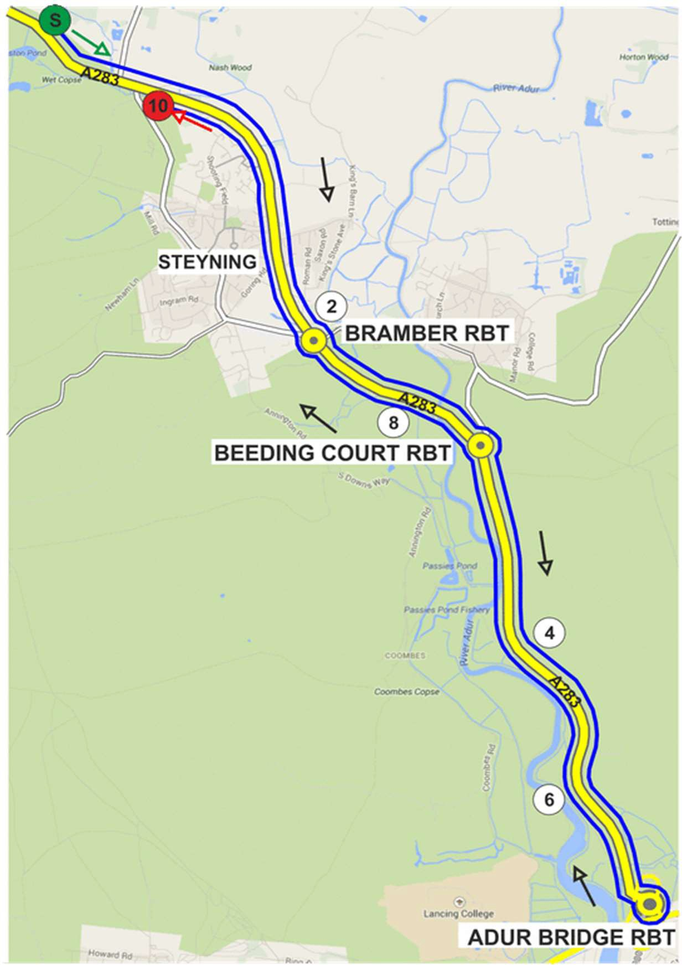
Course Records: Solo Male 00:19:16
Christopher McNamara 18-Jun-22

Solo Female
00:21:31
Joscelin Lowden 22-Jun-19

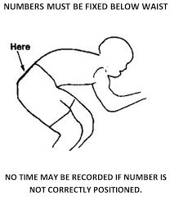
PLEASE MAKE SURE YOU KNOW THE COURSE. There will be signs and marshals at key points to help you and point out any hazards, so please pay attention to them.

No. | Start | Rider | CTT ID | Club | Machine | Cat
1 | 7:01 | David Williams | 47730 | Crawley Wheelers | Road | SM
2 | 7:02 | Jack Olney | 47805 | Crawley Wheelers | Road | SM
3 | 7:03 | Georgina Wise | 34292 | Crawley Wheelers | Road | SF
4 | 7:04 | Matt Ruxton | 44612 | Crawley Wheelers | Road | SM
5 | 7:05 | Simon McLeod | 30098 | Team TMC | Road | SM
6 | 7:06 | Darren Humphrey | 41189 | Sussex Revolution Velo Club | Road | VM
7 | 7:07 | David Marshall | 4596 | Hemel Hempstead CC | Road | VM
8 | 7:08 | James Bullen | 13422 | trainSharp | Road | SM
9 | 7:09
10 | 7:10
11 | 7:11
12 | 7:12 | Jamie Smith | 5948 | Brighton Mitre CC | TT | VM
13 | 7:13 | Erica Martin | 9551 | Eastbourne Rovers CC | TT | VF
14 | 7:14 | Mark Gidney | 39 | Southborough & Dist. Whs | TT | VM
15 | 7:15 | Oliver Stevens | 46288 | Southborough & Dist. Whs | TT | VM
16 | 7:16 | David Smith | 6384 | VC de Londres | TT | VM
17 | 7:17 | Scott Bartha | 26561 | Brighton Excelsior CC | TT | VM
18 | 7:18 | Brian Molloy | 4754 | Brighton Mitre CC | TT | VM
19 | 7:19 | Simon Craig-McFeely | 8003 | …a3crg | TT | VM
20 | 7:20 | Martin Cade | 42590 | Cranleigh Cycling Club | TT | VM
21 | 7:21 | Mike Boyce | 1206 | …a3crg | TT | VM
22 | 7:22 | Lucas Houghton | 34547 | Team TMC | TT | JM
23 | 7:23 | John McDonald | 29220 | trainSharp | TT | VM
24 | 7:24 | Martin Tickner | 300915 | Horsham Cycling | TT | VM
25 | 7:25 | Mark Thomas | 483 | Bigfoot CC | TT | VM
26 | 7:26 | Sam Dix | 3050 | trainSharp | TT | VM
27 | 7:27 | Lisa Davis | 3327 | DRAG2ZERO | TT | VF
28 | 7:28 | Nolan Heather | 4282 | Horsham Cycling | TT | VM
29 | 7:29 | Simon Church | 5649 | trainSharp | TT | VM
30 | 7:30 | Tom Houghton | 197 | Team TMC | TT | VM
31 | 7:31 | Chris Lord | 6603 | Brighton Excelsior CC | TT | VM
32 | 7:32 | Benjamin Tappenden | 21179 | Precise Performance RT | TT | SM
33 | 7:33 | Richard Gifford | 2650 | trainSharp | TT | VM
34 | 7:34 | Cris Coxon | 27241 | Brighton Mitre CC | TT | VM
35 | 7:35 | Brett Davis | 5007 | DRAG2ZERO | TT | VM

